|  |  |
| --- | --- |
| cetlogo ***CHEMICAL ENGINEERING TRANSACTIONS***  ***VOL. , 2025*** | A publication of  aidiclogo_grande |
| The Italian Association  of Chemical Engineering  Online at www.cetjournal.it |
| Guest Editors: Laura Piazza, Francesco Donsì, Giorgia Spigno  Copyright © 2025, AIDIC Servizi S.r.l. **ISBN** 979-12-81206-19-9; **ISSN** 2283-9216 | |

Tailored Co-Extruded Cereals for Seniors: A Design Thinking Approach to Functional Food Development.

Leehen Mashiah a, Omer Medini b, Andrea Araiza Calahorra c, Carmit Shani Levi a, Anwesha Sarkar c , Uri Lesmes a,\*

a Laboratory of Chemistry of Foods and Bioactives,Department of Biotechnology and Food Engineering, Technion – Israel Institute of Technology, Haifa, Israel

b The International Beer Breweries LTD, Kibbutz, Givat Haim, M.P. Hefer, 3893000, Israel

c Food Colloids and Bioprocessing Group, School of Food Science and Nutrition, University of Leeds, Leeds, LS2 9JT, UK

\* Corresponding Author: Prof. Uri Lesmes

Laboratory of Chemistry of Foods and Bioactives

Department of Biotechnology and Food Engineering,

Technion – Israel Institute of Technology, Haifa 32000,

Israel

Email: [lesmesu@bfe.technion.ac.il](mailto:lesmesu@bfe.technion.ac.il)

The increasing gap between lifespan and health span calls for innovative approaches to promote healthy aging. This study, part of the EAT4AGE project under the Joint Programming Initiative 'A Healthy Diet for a Healthy Life', focuses on developing functional foods for older adults. A co-extruded cereal prototype fortified with Maca root powder and Olive leaf extract was designed to address nutritional needs of older adults, particularly high-quality, easily digestible proteins.

Analytical results show the cereals have a rich macronutrient profile with over 12% (w/w) protein, 20% (w/w) fat, and low sugar content (<5% w/w), surpassing commercial alternatives. Texture analyses indicate improved hardness and reduce oral friction. An untrained consumer panel (n=21, Age 73±5) reported high palatability and overall acceptability, which was confirmed by a trained sensory panel.

The product's digestion was evaluated using an age-tailored in vitro digestion model, consistently demonstrating high protein digestibility exceeding 80% across all formulations. The calculated in vitro digestible indispensable amino acid score affirms the product's high nutritional quality. This research highlights the potential for designing palatable foods that could contribute to a balanced and sustainable diet for healthy aging.

* 1. Introduction

The National Institutes of Health (NIH), U.S. observed a significant increase in human lifespan that has not been matched by a corresponding increase in human healthspan (Brett et al., 2019; He et al., n.d.). This trend is accompanied by growing efforts to maximize the potential of plant-based foods for healthier and more sustainable diets (Green et al., 2022; Willett et al., 2019). Consequently, the development of customized nutritional solutions can substantially impact on the independence, quality of life, and healthy aging of older adults by addressing many age-related challenges.

These solutions need to consider relevant age-related physiological declines, such as changes in salivation, reduced jaw strength, swallowing difficulties, slower stomach emptying, decreased secretion of digestive fluids, and altered gut microbiota, along with reduced appetite and early satiety (Biagi et al., 2016; Claesson et al., 2012; Menard et al., 2023; Rémond et al., 2015; Sarkar, 2019). Furthermore, designing foods for older adults requires addressing age-related cognitive decline and changes in eating patterns, where potential sensory deterioration may contribute to malnutrition and insufficient protein intake, negatively affecting health (Dent et al., 2023; Hu, 2024a; Morgan et al., 2023; Rémond et al., 2015).

Currently, there is increasing consumer and commercial interest in food and dietary solutions that can effectively meet the unique preferences, acceptance, and needs of seniors (Hu, 2024a; Rémond et al., 2015). This led to an ERA-Net ERA-HDHL call for the "Development of targeted nutrition for prevention of undernutrition for older adults" (PREVNUT). The EAT4AGE consortium responded to this challenge by targeting the development of palatable nutrient-dense functional foods.

A literature review within this project identified actual nutritional gaps in older adults, with high-quality protein, dietary fibers, and specific micronutrients like calcium and iron set as viable targets (Bruins et al., 2019; Hu, 2024b; Morgan et al., 2023; Phillips, 2021; Putra et al., 2021). Protein was found to be particularly important as a robust dietary intervention tool to address age-related muscle loss (sarcopenia), promote healthy muscle aging, and even help regulate appetite (Gosby et al., 2011, 2014; Hu, 2024b; Nunes et al., 2022).

This research aimed to design and study the potential digestive fate of a co-extruded cereal product for seniors (age >65). The product was formulated as a functional food with two added bioactive components: Maca and Olive Leaf Extract (OLE). The study focused on the palatability of the functional product, its oral processing, and the potential digestibility of its proteins in healthy seniors. The underlying hypothesis was that seniors have different food preferences and digestive capabilities which affect their perception and breakdown of the tailored cereal product.

* 1. Results and Discussion

This study, a contribution to the EAT4AGE project, sought to develop an innovative food solution specifically tailored to address the nutritional challenges faced by older adults. The research focused on the creation, characterization, sensory evaluation, and in vitro digestive behavior of novel plant-based cereal prototypes designed with the goal of promoting healthy aging.

* + 1. Characterization of Cereal Prototypes

**Proximate Composition:** The cereal prototypes were analyzed for their macronutrient composition. Results indicated a protein content exceeding 12% (w/w), a fat content of around 20% (w/w), and a low sugar content (less than 5%w/w). This nutritional profile compares favorably to existing commercial cereal products often consumed by seniors, which typically exhibit lower protein levels and significantly higher sugar content. The prototypes also boasted a substantial dietary fiber content of 17% (w/w), reflecting the importance of fiber for digestive health in older adults (Meyer et al., 2000; Park et al., 2009; Streppel et al., 2008; Sturtzel et al., 2009; Tucker & Thomas, 2009; Wood et al., 2007). Research emphasizes the importance of micronutrients like Iron, Zinc, Copper, and Selenium in older adult nutrition (Bruins et al., 2019; Kehoe et al., 2019; Rémond et al., 2015). Cereals often lack sufficient quantities of these nutrients. Incorporating legumes, such as chickpeas, can compensate for the amino acid profile and micronutrient deficiencies in cereals, particularly iron content. Combining these complementary sources enhances the nutritional profile of extruded cereal products. However, the success of these healthier food options depends on balancing their nutritional benefits with consumer acceptance based on taste and palatability.

**Instrumental Texture Analysis:** The textural properties of the cereal prototypes, including hardness and Young's modulus, were assessed using single compression testing (**Figure 1. A+B**). The addition of functional ingredients, specifically Maca and Olive Leaf Extract (OLE), led to a significant reduction in the hardness of the cereal samples (p<0.05). This reduction in hardness may translate to improved ease of chewing and greater oral comfort for older adults, particularly those experiencing age-related difficulties with mastication. Differences in Young’s modulus were minimal across formulations, suggesting that these added ingredients do not dramatically alter the overall structural integrity of the product.

**Tribological Properties:** A ball-on-disk tribometer was employed to examine the lubricating properties of the cereal prototypes during simulated oral processing (**Figure 1.C**). Friction curves revealed distinct tribological behaviors depending on the specific formulation. The Maca+OLE formulation exhibited characteristics suggesting a transition through boundary, mixed, and hydrodynamic lubrication regimes, which may be associated with the release of oils during mastication. Confocal microscopy supported the idea that the dispersion of oil droplets may play a role in lubricating properties. Microscopic imaging of bolus samples demonstrated smaller protein fragments and uniformly distributed smaller oil droplets in the presence of Maca and OLE, suggesting potentially enhanced breakdown of the food structure during digestion.

**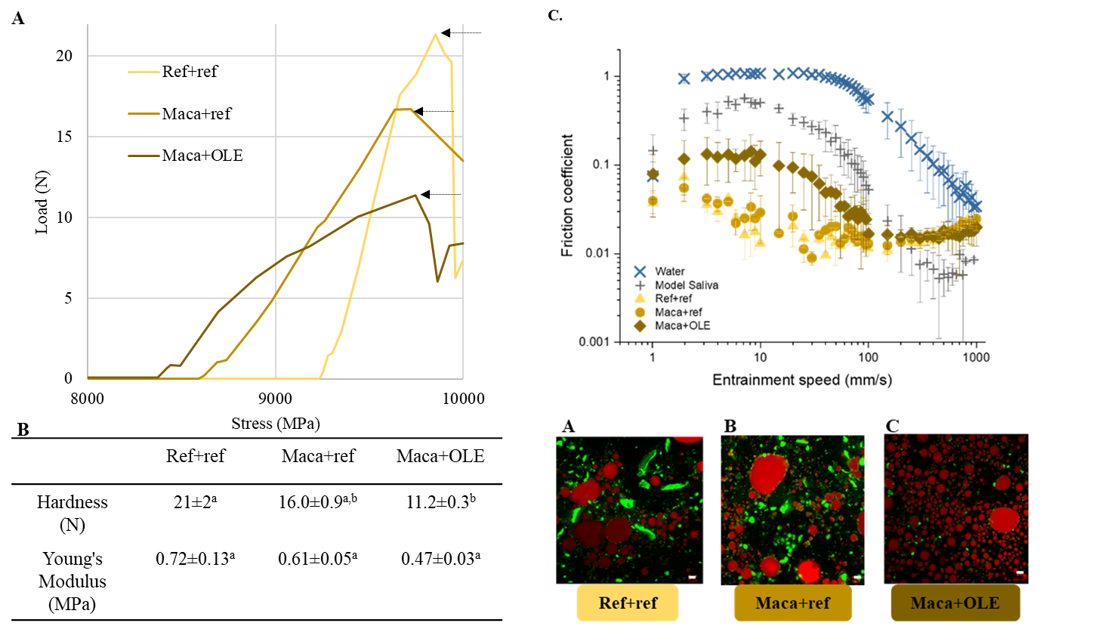**

**Figure 2. Texture Profile Analysis (TPA) for plant-based prototypes- Enhancing oral comfort through functional materials** **Addition. (A)** Strength to strain TPA graph **(B)** Summary table of textural properties values. Values (mean ± SD) in the same line followed by a different letter are significantly different (p<0.05). **(C) Mean friction coefficients as a function of entrainment speeds and CLSM images of** Ref+ref,Maca+ref,Maca+OLE.Protein aggregates are stained fluorescently green using Fast green whilst fat droplets are stained fluorescently red using Nile Red. The friction curve of water and model saliva are added as reference. Data represent average of triplicate measurements on three samples (n = 2 × 3).

* + 1. *In Vivo* Sensory Evaluation:

**Food Comfortability:** Questionnaires following a procedure described previously(Vandenberghe-Descamps et al., 2017, 2018) were administered to an elderly consumer panel (n=21, Age 73±5 years) to assess various aspects of food comfortability, including ease of bolus formation, absence of oral pain, and texture sensation. Participants reported high scores for ease of chewing and swallowing, minimal oral pain, and positive textural perceptions described as "crunchy" and "melting" (**Figure 2**). These findings indicate a favorable overall sensory experience for the target consumer group.

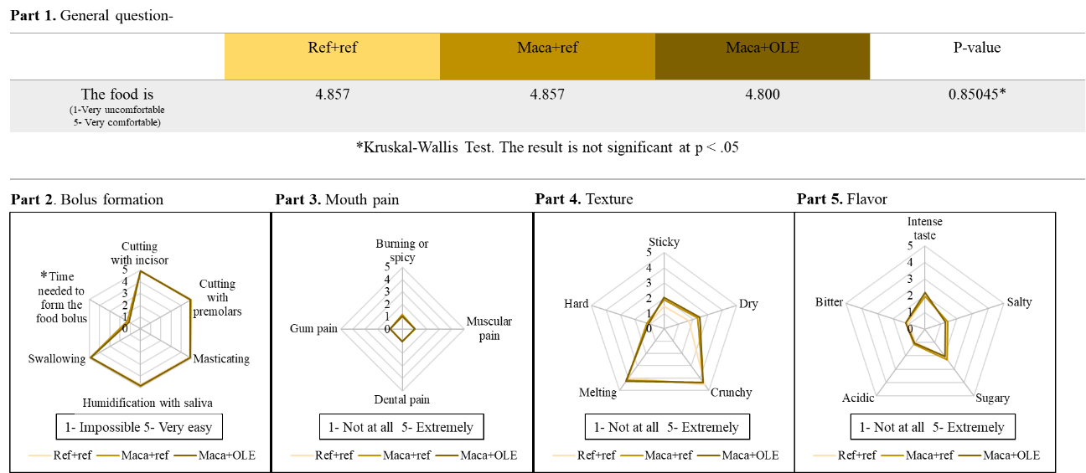

**Figure 2. Results from the questionnaire on the perception of food comfortability.** **Part 1.** General Food Comfort: Rates the overall comfort level of eating the food (scale: "Very Uncomfortable" to "Very Comfortable"). **Part 2.** Bolus Formation and Time Needed: Evaluates the ease of bolus formation (scale: "Impossible" to "Very Easy") and the time required for it (scale: "Impossible" to "Very Brief"). **Part 3.** Pain Perception: Measures the level of pain experienced while eating (scale: "Extremely" to "Not at All"). **Part 4.** Texture Perception: Assesses the perception of food texture (scale: "Extremely" to "Not at All").

**Part 5.** Flavor Perception: Evaluates the intensity of flavor perception (scale: "Extremely" to "Not at All").

* + 1. *In Vitro* Protein Digestion:

Protein digestion was evaluated using a semi-dynamic in vitro digestion model simulating conditions relevant to both young adults and older adults (Menard et al., 2023). SDS-PAGE was utilized to visualize the protein digestion process. While protein breakdown patterns were similar across different formulations (**Figure 3. 2.A-C**), the pre-extruded product exhibited limited protein release (**Figure 3. 1.A+C**). In contrast, the extruded products demonstrated enhanced protein bioaccessibility (**Figure 3. 1.B+D**). When comparing digestion between simulated young adult and elderly conditions, it was observed that protein breakdown proceeded more slowly under simulated elderly conditions.

Moreover, this study evaluated protein quality using the DIAAS method for a functional food product, finding no significant digestibility differences between adults and seniors. Processing increased protein digestibility to over 80%, surpassing typical plant-based protein digestibility (Orlien et al., 2021; Sá et al., 2020; Sousa et al., 2023). DIAAS values were calculated for pre- and post-extruded products, with lysine and tryptophan as limiting amino acids. While co-extrusion may decrease bioaccessibility of specific amino acids, the combined formulation of four flours yielded a palatable product with high digestibility scores, even under simulated conditions of older adults' gut. This research demonstrates the potential for producing nutritionally rich cereal products using sustainable plant-based protein sources.

**Figure 3. (1) Consistent protein breakdown pattern: SDS-PAGE analyses of senior digestion for post-extruded products. (A)** Ref+ref, **(B)** Maca+ref, **(C)** Maca+OLE. **(2) Comparative SDS-PAGE analyses of digesta samples: Enhanced proteolysis in post-extruded products (Maca+OLE) and reduced proteolysis in senior *in vitro* digestion vs. adult. (A+C)** Protein breakdown patterns of the pre-extruded (Mix+maca) **(B+D)** and post-extruded product (Maca+OLE) under senior **(A+B)** and adult (**C+D)** *in vitro* digestion conditions. **(3) High *In vitro* Digestibility highlighted in results. (A)** Comparative protein digestibility percentages in different cereal products pre- and post-extrusion under adult and senior IVD models, **(B)** Table presenting digestibility percentages of individual AAs. Values are expressed as the mean ± SD. Different letters denote significant differences (p<0.05)

* 1. Conclusion:

This research underscores the critical role of nutrition in promoting healthy aging through the development of age-tailored functional foods. Aligning with the EAT-Lancet report's recommendations for healthier and more sustainable food choices, the study developed plant-based, co-extruded cereals with superior macronutrient profiles and high in vitro digestibility (>80%) for the aging population. The work emphasizes the importance of balancing nutritional value with consumer enjoyment, contributing to efforts addressing the health gap in the growing global aging demographic. By encouraging further collaboration between industry and academia, this research aims to bridge the gap between in vitro analyses and real-world efficacy. Ultimately, this study seeks to stimulate innovation in nutritionally optimized products, highlighting the need for tailored food solutions that meet both nutritional requirements and consumer preferences to improve health and quality of life for older adults.

References

Biagi, E., Franceschi, C., Rampelli, S., Capri, M., Brigidi, P., & Candela Correspondence, M. (2016). Gut Microbiota and Extreme Longevity. *Current Biology*, *26*, 1480–1485. https://doi.org/10.1016/j.cub.2016.04.016

Brett, C. E., Dykiert, D., Starr, J. M., & Deary, I. J. (2019). Predicting change in quality of life from age 79 to 90 in the Lothian Birth Cohort 1921. *Quality of Life Research*, *28*(3), 737–749. https://doi.org/10.1007/S11136-018-2056-4/TABLES/4

Bruins, M. J., Van Dael, P., & Eggersdorfer, M. (2019). The role of nutrients in reducing the risk for noncommunicable diseases during aging. In *Nutrients* (Vol. 11, Issue 1). MDPI AG. https://doi.org/10.3390/nu11010085

Claesson, M. J., Jeffery, I. B., Conde, S., Power, S. E., O’connor, E. M., Cusack, S., Harris, H. M. B., Coakley, M., Lakshminarayanan, B., O’sullivan, O., Fitzgerald, G. F., Deane, J., O’connor, M., Harnedy, N., O’connor, K., O’mahony, D., Van Sinderen, D., Wallace, M., Brennan, L., … O’toole, P. W. (2012). Gut microbiota composition correlates with diet and health in the elderly. *Nature 2012 488:7410*, *488*(7410), 178–184. https://doi.org/10.1038/nature11319

Dent, E., Wright, O. R. L., Woo, J., & Hoogendijk, E. O. (2023). Malnutrition in older adults. *The Lancet*, *401*(10380), 951–966. https://doi.org/10.1016/S0140-6736(22)02612-5

Gosby, A. K., Conigrave, A. D., Lau, N. S., Iglesias, M. A., Hall, R. M., Jebb, S. A., Brand-Miller, J., Caterson, I. D., Raubenheimer, D., & Simpson, S. J. (2011). Testing protein leverage in lean humans: A randomised controlled experimental study. *PLoS ONE*, *6*(10). https://doi.org/10.1371/journal.pone.0025929

Gosby, A. K., Conigrave, A. D., Raubenheimer, D., & Simpson, S. J. (2014). Protein leverage and energy intake. *Obesity Reviews*, *15*(3), 183–191. https://doi.org/10.1111/OBR.12131

Green, A., Blattmann, C., Chen, C., & Mathys, A. (2022). The role of alternative proteins and future foods in sustainable and contextually-adapted flexitarian diets. *Trends in Food Science & Technology*, *124*, 250–258. https://doi.org/10.1016/J.TIFS.2022.03.026

He, W., Goodkind, D., & Kowal, P. (n.d.). *An Aging World: 2015*.

Hu, F. B. (2024a). Diet strategies for promoting healthy aging and longevity: An epidemiological perspective. *Journal of Internal Medicine*, *295*(4), 508–531. https://doi.org/10.1111/joim.13728

Hu, F. B. (2024b). Diet strategies for promoting healthy aging and longevity: An epidemiological perspective. *Journal of Internal Medicine*, *295*(4), 508–531. https://doi.org/10.1111/JOIM.13728

Kehoe, L., Walton, J., & Flynn, A. (2019). *Conference on ‘Targeted approaches to tackling current nutritional issues’ Postgraduate Symposium Nutritional challenges for older adults in Europe: current status and future directions*. https://doi.org/10.1017/S0029665118002744

Menard, O., Lesmes, U., Shani-Levi, C. S., Araiza Calahorra, A., Lavoisier, A., Morzel, M., Rieder, A., Feron, G., Nebbia, S., Mashiah, L., Andres, A., Bornhorst, G., Carrière, F., Egger, L., Gwala, S., Heredia, A., Kirkhus, B., Macierzanka, A., Portman, R., … Dupont, D. (2023). Static in vitro digestion model adapted to the general older adult population: an INFOGEST international consensus. *Food & Function*. https://doi.org/10.1039/D3FO00535F

Meyer, K. A., Kushi, L. H., Jacobs, D. R., Slavin, J., Sellers, T. A., & Folsom, A. R. (2000). Carbohydrates, dietary fiber, and incident type 2 diabetes in older women. *The American Journal of Clinical Nutrition*, *71*(4), 921–930. https://doi.org/10.1093/AJCN/71.4.921

Morgan, P. T., Witard, O. C., Højfeldt, G., Church, D. D., Breen, L., & Morgan, P. (2023). Dietary protein recommendations to support healthy muscle ageing in the 21st century and beyond: considerations and future directions. *Proceedings of the Nutrition Society*, 1–14. https://doi.org/10.1017/S0029665123003750

Nunes, E. A., Colenso-Semple, L., McKellar, S. R., Yau, T., Ali, M. U., Fitzpatrick-Lewis, D., Sherifali, D., Gaudichon, C., Tomé, D., Atherton, P. J., Robles, M. C., Naranjo-Modad, S., Braun, M., Landi, F., & Phillips, S. M. (2022). Systematic review and meta-analysis of protein intake to support muscle mass and function in healthy adults. In *Journal of Cachexia, Sarcopenia and Muscle* (Vol. 13, Issue 2, pp. 795–810). John Wiley and Sons Inc. https://doi.org/10.1002/jcsm.12922

Orlien, V., Aalaei, K., Poojary, M. M., Nielsen, D. S., Ahrné, L., & Carrascal, J. R. (2021). Effect of processing on in vitro digestibility (IVPD) of food proteins. *Critical Reviews in Food Science and Nutrition*, *0*(0), 1–50. https://doi.org/10.1080/10408398.2021.1980763

Park, Y., Brinton, L. A., Subar, A. F., Hollenbeck, A., & Schatzkin, A. (2009). Dietary fiber intake and risk of breast cancer in postmenopausal women: the National Institutes of Health–AARP Diet and Health Study. *The American Journal of Clinical Nutrition*, *90*(3), 644–651. https://doi.org/10.3945/AJCN.2009.27758

Phillips, J. A. (2021). Dietary Guidelines for Americans, 2020–2025. *Https://Doi.Org/10.1177/21650799211026980*, *69*(8), 395. https://doi.org/10.1177/21650799211026980

Putra, C., Konow, N., Gage, M., York, C. G., & Mangano, K. M. (2021). Protein Source and Muscle Health in Older Adults: A Literature Review. *Nutrients 2021, Vol. 13, Page 743*, *13*(3), 743. https://doi.org/10.3390/NU13030743

Rémond, D., Shahar, D. R., Gille, D., Pinto, P., Kachal, J., Peyron, M. A., Dos Santos, C. N., Walther, B., Bordoni, A., Dupont, D., Tomás-Cobos, L., & Vergères, G. (2015). Understanding the gastrointestinal tract of the elderly to develop dietary solutions that prevent malnutrition. *Oncotarget*, *6*(16), 13858. https://doi.org/10.18632/ONCOTARGET.4030

Sá, A. G. A., Moreno, Y. M. F., & Carciofi, B. A. M. (2020). Food processing for the improvement of plant proteins digestibility. *Critical Reviews in Food Science and Nutrition*. https://doi.org/10.1080/10408398.2019.1688249

Sarkar, A. (2019). Oral processing in elderly: understanding eating capability to drive future food texture modifications. *Proceedings of the Nutrition Society*, *78*(3), 329–339. https://doi.org/10.1017/S0029665118002768

Sousa, R., Recio, I., Heimo, D., Dubois, S., Moughan, P. J., Hodgkinson, S. M., Portmann, R., & Egger, L. (2023). In vitro digestibility of dietary proteins and in vitro DIAAS analytical workflow based on the INFOGEST static protocol and its validation with in vivo data. *Food Chemistry*, *404*, 134720. https://doi.org/10.1016/J.FOODCHEM.2022.134720

Streppel, M. T., Ocké, M. C., Boshuizen, H. C., Kok, F. J., & Kromhout, D. (2008). Dietary fiber intake in relation to coronary heart disease and all-cause mortality over 40 y: the Zutphen Study. *The American Journal of Clinical Nutrition*, *88*(4), 1119–1125. https://doi.org/10.1093/AJCN/88.4.1119

Sturtzel, B., Mikulits, C., Gisinger, C., & Elmadfa, I. (2009). Use of fiber instead of laxative treatment in a geriatric hospital to improve the wellbeing of seniors. *Journal of Nutrition, Health and Aging*, *13*(2), 136–139. https://doi.org/10.1007/S12603-009-0020-2/METRICS

Tucker, L. A., & Thomas, K. S. (2009). Increasing Total Fiber Intake Reduces Risk of Weight and Fat Gains in Women. *The Journal of Nutrition*, *139*(3), 576–581. https://doi.org/10.3945/JN.108.096685

Vandenberghe-Descamps, M., Labouré, H., Septier, C., Feron, G., & Sulmont-Rossé, C. (2018). Oral comfort: A new concept to understand elderly people’s expectations in terms of food sensory characteristics. *Food Quality and Preference*, *70*, 57–67. https://doi.org/10.1016/J.FOODQUAL.2017.08.009

Vandenberghe-Descamps, M., Sulmont-Rossé, C., Septier, C., Feron, G., & Labouré, H. (2017). Using food comfortability to compare food’s sensory characteristics expectations of elderly people with or without oral health problems. *Journal of Texture Studies*, *48*(4), 280–287. https://doi.org/10.1111/jtxs.12250

Willett, W., Rockström, J., Loken, B., Springmann, M., Lang, T., Vermeulen, S., Garnett, T., Tilman, D., DeClerck, F., Wood, A., Jonell, M., Clark, M., Gordon, L. J., Fanzo, J., Hawkes, C., Zurayk, R., Rivera, J. A., De Vries, W., Majele Sibanda, L., … Murray, C. J. L. (2019). Food in the Anthropocene: the EAT–Lancet Commission on healthy diets from sustainable food systems. In *The Lancet* (Vol. 393, Issue 10170, pp. 447–492). Lancet Publishing Group. https://doi.org/10.1016/S0140-6736(18)31788-4

Wood, R. J., Fernandez, M. L., Sharman, M. J., Silvestre, R., Greene, C. M., Zern, T. L., Shrestha, S., Judelson, D. A., Gomez, A. L., Kraemer, W. J., & Volek, J. S. (2007). Effects of a carbohydrate-restricted diet with and without supplemental soluble fiber on plasma low-density lipoprotein cholesterol and other clinical markers of cardiovascular risk. *Metabolism*, *56*(1), 58–67. https://doi.org/10.1016/J.METABOL.2006.08.021